MANIPAL UNIVERSITY JAIPUR
Department of Computer Science and Engineering
Predictive Analytics (CSE3141)
Project Report 2026
Predicting Bike-Sharing Demand
Classification, Count Regression and Time-Series Forecasting on the Capital Bikeshare Data (Washington D.C., 2011–2012)
Name: | Atreya Mitra
Registration No.: | 2427030002
Programme: | B.Tech Computer Science and Engineering

October 2026

Abstract
Bike-sharing operators must decide, hour by hour, how many bikes to place where. This project builds an end-to-end predictive-analytics pipeline for that decision using the public UCI Bike Sharing Dataset (17,379 hourly records, 2011-01-01 to 2012-12-31). One real dataset is used to cover every unit of the syllabus: data preparation and exploration, logistic regression and inference (binary and multinomial logit, LDA, QDA, Gaussian/Poisson/Negative Binomial GLMs), time-series analysis (ARIMA, SARIMA, exponential smoothing, SARIMAX) and model validation and optimisation (cross-validation, RMSE, MAE, F1, AUC-ROC, grid and random search, over/under-fitting).
Key results: (1) a logistic model identifies 'high-demand' hours with AUC 0.954 and gives interpretable odds ratios (rain or snow cuts the odds of a high-demand hour by about 88 %); (2) a tuned gradient-boosting classifier reaches F1 = 0.945 and AUC = 0.986 on unseen data; (3) hourly counts are heavily overdispersed (Poisson dispersion 14.28), so a Negative Binomial GLM is the statistically valid choice for inference, while a random forest gives the lowest RMSE (44.1 rentals/hour); (4) for 60-day daily forecasts, univariate models cannot anticipate the winter downturn, whereas a regression with SARIMA errors that uses weather and calendar information reduces RMSE by about 16 % relative to the best univariate model; (5) random K-fold cross-validation is over-optimistic for time-ordered data, which is shown explicitly. Limitations and ethical considerations are discussed.

Contents
1. Introduction
2. Data Preparation and Exploration
3. Logistic Regression and Inference
4. Time Series Analysis
5. Model Validation and Optimization
6. Discussion and Recommendations
7. Conclusion
References
Appendix A: Syllabus coverage map
Appendix B: Reproducing the results

1. Introduction

1.1 What is predictive analytics?
Predictive analytics is the use of historical data, statistical models and machine learning to estimate the probability or value of something that has not been observed yet. It matters because organisations act before outcomes are known: a bike-sharing company must move bikes before the evening rush, not after it. Its scope runs from data collection and cleaning, through model building and inference, to validation and deployment, and it is only useful when the predictions are measured honestly on data the model has not seen.

1.2 Predictive, descriptive and prescriptive analytics
Table 1. The three types of analytics and where each appears in the project
Type | Question answered | In this project
Descriptive | What happened? | EDA: hourly profile, monthly trend, weather effects (Section 2)
Predictive | What will happen? | Classifying high-demand hours, predicting counts, forecasting daily demand (Sections 3–5)
Prescriptive | What should we do? | Staffing and rebalancing recommendations built on the predictions (Section 6)

1.3 Role of predictive analytics in industry
- Finance: logistic regression and discriminant analysis underpin credit scoring and fraud detection; ARIMA-type models and exponential smoothing are used for volatility and price forecasting. The same time-series toolkit used here for demand applies to stock-price analysis.
- Healthcare: classification models flag patients at risk of readmission; count models (Poisson, Negative Binomial) model hospital admissions and disease cases, which are overdispersed just like our rental counts.
- Marketing: churn prediction, response modelling and demand forecasting for campaigns and inventory.
- IT: capacity planning, anomaly detection and workload forecasting. Our demand forecasts are the same kind of problem as predicting server load.

1.4 Ethical considerations in predictive modelling
- Privacy: trip-level mobility data can reveal where people live and work. The dataset used here is aggregated by hour with no rider identifiers; a real deployment should keep it that way or apply formal anonymisation.
- Fairness: a model trained on past rentals learns where demand already exists. Using it to decide where to put bikes can starve under-served neighbourhoods and reinforce the pattern (a feedback loop). Equity targets should be set explicitly.
- Transparency: operators and regulators should be able to see why a prediction was made. This is one reason the report keeps interpretable models (odds ratios, rate ratios) alongside the more accurate tree ensembles.
- Evaluation integrity: leakage (e.g. using casual + registered riders to predict their total) and random cross-validation on time-ordered data produce flattering but false results. Both are checked in this project.
- Robustness and misuse: extreme events such as hurricanes break statistical assumptions; predictions should come with uncertainty and a human in the loop.

1.5 Problem statement and objectives
Given weather, calendar and time-of-day information, predict bike-sharing demand in a way that supports operational decisions. Concretely the project aims to:
- prepare and explore the data, handling missing values, outliers and redundant features;
- classify each hour as low- or high-demand (binary), and into three demand levels (multinomial), and compare logistic regression, LDA and QDA;
- model hourly counts with generalised linear models and choose between Gaussian, Poisson and Negative Binomial families;
- forecast daily demand with ARIMA, SARIMA, exponential smoothing and SARIMAX;
- validate and tune every model with appropriate cross-validation, metrics and hyper-parameter search, and diagnose over- and under-fitting.

1.6 Dataset
The Capital Bikeshare data for Washington D.C. is distributed by the UCI Machine Learning Repository (Fanaee-T and Gama, 2014). Two files are used: hour.csv (17,379 rows, one per hour with at least one rental) and day.csv (731 rows, one per day). Weather variables are normalised in the file and were converted back to real units.
Table 2. Main variables of the UCI Bike Sharing Dataset
Variable | Meaning | Type
cnt (target) | Total rentals in the hour (casual + registered) | Count
hr, mnth, season, weekday | Hour 0–23, month, season (1 = winter … 4 = fall), day of week | Categorical
yr, holiday, workingday | Year (0 = 2011, 1 = 2012), public holiday, working-day flags | Binary
weathersit | 1 clear, 2 mist/cloud, 3 light rain/snow, 4 heavy rain/snow | Ordinal
temp, atemp, hum, windspeed | Temperature, feels-like temperature, humidity, wind speed (normalised) | Numeric
casual, registered | Rentals by non-members / members (cnt = casual + registered) | Count

2. Data Preparation and Exploration

2.1 Data collection and real-world challenges
The data come from automated docking-station logs merged with hourly weather and a holiday calendar. Typical real-world issues appear even in this tidy public file. First, hours with zero rentals are absent: 17,379 rows exist but 731 days × 24 h = 17,544, so 165 hours are implicitly missing (mostly night hours in which nobody rented). Second, sensor and merge errors produce impossible values. Third, weather is measured at city level, not at each station. Fourth, the data are only two years long, which limits what any model can learn about annual cycles.

2.2 Cleaning: missing values, impossible values and outliers
The file has no formally missing cells (0 NaN) and no duplicate rows (0). A leakage check confirmed that cnt = casual + registered for every row, so those two columns were excluded as predictors.
Impossible values. Humidity equals exactly 0 % in 22 hourly rows, all on 2011-03-10, which is physically implausible in Washington D.C. These were treated as missing and imputed with the median humidity of the same year-month. Wind speed is recorded as 0 in 2,180 rows (13 %), which looks like a sensor resolution limit rather than calm air; it was left unchanged and is noted as a limitation.
Outliers. With the 1.5 × IQR rule, 505 hourly rental counts (above 642) and 342 wind-speed readings (above 32 km/h) were flagged. The demand peaks are genuine rush-hour events and were kept, since deleting them would remove the very signal we want to predict. Extreme wind gusts were winsorised (capped at the upper fence). Temperature and humidity had no outliers.
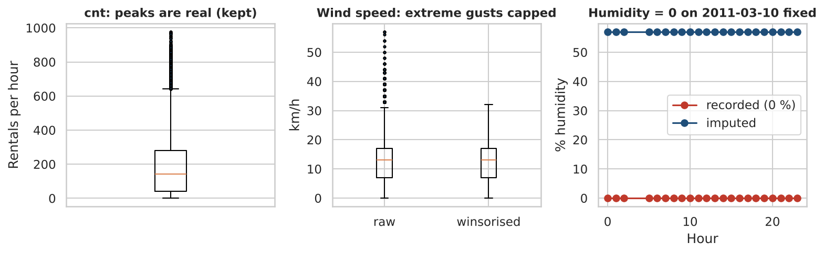
Figure 1. Outlier handling: demand peaks kept, extreme wind capped, impossible humidity values imputed.

2.3 Exploratory data analysis
Hourly demand has mean 189, median 142, standard deviation 181 and ranges from 1 to 977 rentals. The distribution is right-skewed (Figure 2, left) and, importantly, the variance is far above the mean in every hour of the day (Figure 2, right), a sign of overdispersion that matters in Section 3.4.
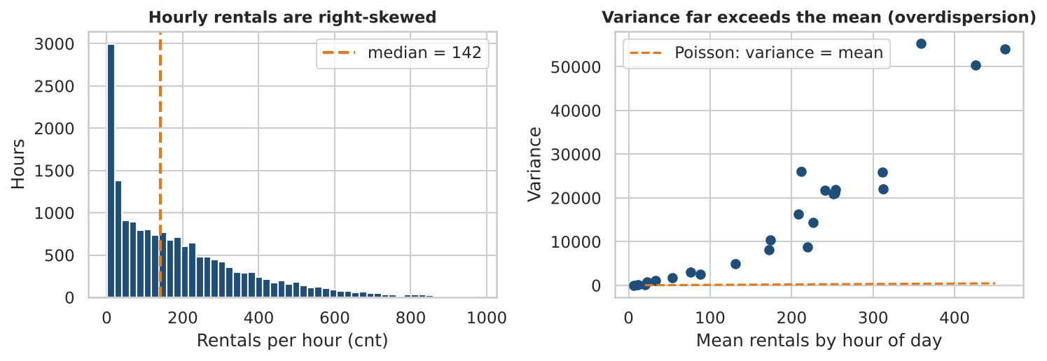
Figure 2. Left: distribution of hourly rentals with the median used as the high-demand threshold. Right: variance versus mean by hour.
Time of day. On working days demand has two commuter peaks, one at 08:00 (about 477 rentals per hour) and a higher evening peak at 17:00 (about 525) and 18:00 (about 492); on weekends and holidays there is a single leisure hump peaking at 13:00 (about 373). The two daily shapes are so different that the model must allow the hour effect to depend on the type of day.
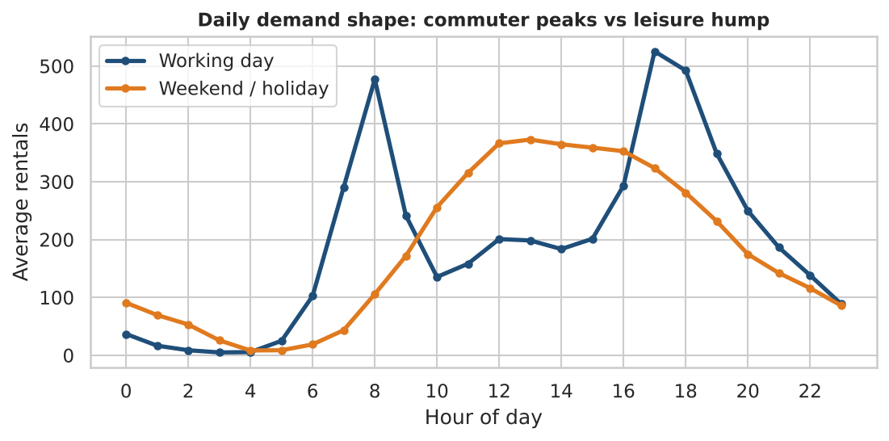
Figure 3. Average rentals by hour of day, working days versus weekends/holidays.
Seasonality and growth. Demand is lowest in winter and highest in summer and early autumn, and 2012 is above 2011 in every month. The average daily count grew from 3406 to 5600, an increase of 64.4 %. Any model that ignores the year will therefore be biased.
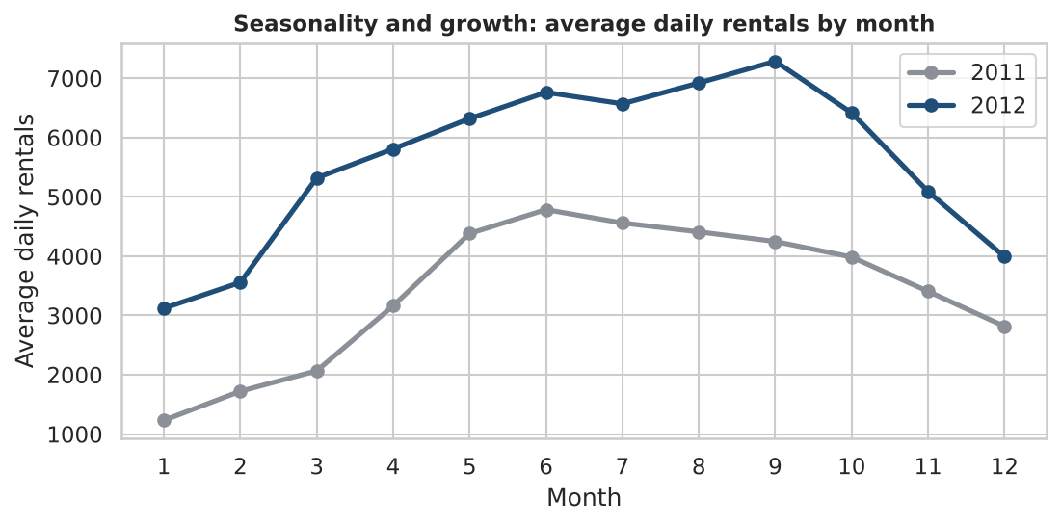
Figure 4. Average daily rentals by month, 2011 versus 2012.
Weather. Average hourly demand is 205 in clear weather, 175 in mist and 112 in rain or snow (the last category has 1,422 hours). Demand rises with temperature, with some flattening at the hottest end.
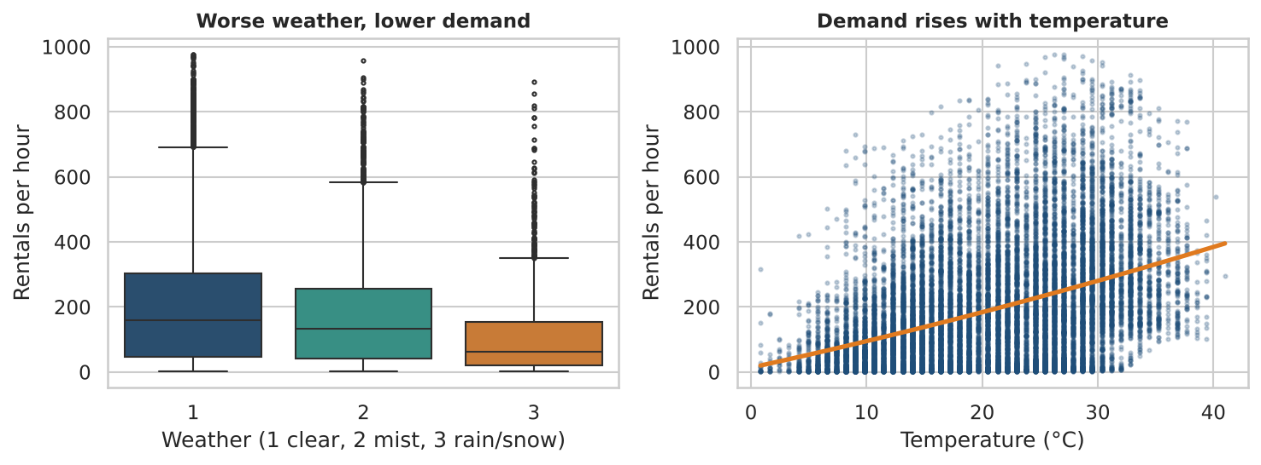
Figure 5. Rentals by weather category (left) and by temperature with a quadratic trend (right).
Correlations. The strongest relationships with cnt are temperature (r = 0.41), humidity (r = -0.33) and hour (r = 0.39, which understates the strong non-linear hour effect). Temperature and feels-like temperature are almost identical (r = 0.9877). The correlations of cnt with registered (0.97) and casual (0.69) are high by construction and are not usable as predictors.
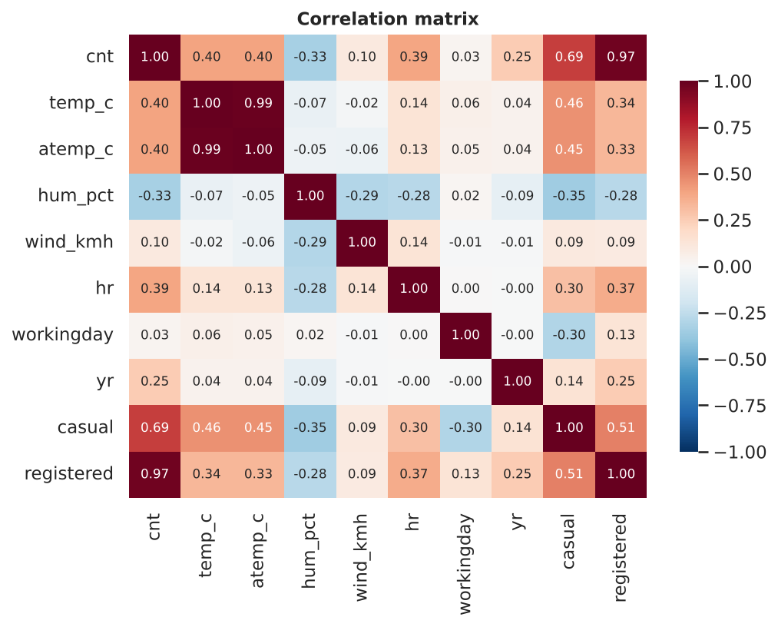
Figure 6. Correlation matrix of the main numeric variables.

2.4 Feature engineering and selection
- Cyclical hour encoding: hour is circular (23:00 is next to 00:00), so sin and cos of 2π·hr/24 are used, plus a second harmonic (period 12 h) that lets a linear model represent two commuter peaks.
- Day-type interaction: the four harmonics are multiplied by the working-day flag so that working days and non-working days have different daily shapes.
- Weather dummies: weathersit 3 and 4 were merged (the heavy-rain category has only 3 rows), then coded as 'mist' and 'bad weather' indicators.
- Real-unit conversion: temperature ×41 (°C), humidity ×100 (%), wind ×67 (km/h).
Multicollinearity. The variance inflation factor (VIF) of temperature and feels-like temperature is 43.6 and 43.7, far above the usual limit of 5–10. Dropping feels-like temperature brings the VIF of temperature to 1.01. Relevance. Mutual information with the high-demand label ranks hour first (0.28), then temperature (0.10) and humidity (0.07); wind speed and holiday carry almost no marginal information but are kept because they are significant in the regression models once other variables are controlled.
Targets and split. The binary target 'high demand' is 1 if cnt exceeds the median (142), giving balanced classes (≈ 50 / 50). The three-level target uses tertiles: low (≤ 70), medium (70–225) and high (> 225). All supervised models share one stratified 80/20 split (13,903 training and 3,476 test rows, random seed 42).

3. Logistic Regression and Inference

3.1 Logistic regression for the binary problem
For a binary outcome y (high demand) and predictors x, logistic regression models the log-odds as linear: log( p / (1 − p) ) = β₀ + β₁x₁ + … + β_k x_k, so that p = 1 / (1 + e^−(β₀ + βx)). Coefficients are estimated by maximum likelihood (iteratively reweighted least squares / Newton–Raphson) because there is no closed form. Each coefficient is a change in log-odds, and exp(β) is an odds ratio (OR). Inference uses Wald z-tests and confidence intervals for single coefficients and the likelihood-ratio (LR) test for the whole model.
The model was fitted with statsmodels on the training set. The LR test against the intercept-only model is highly significant (χ² = 12,221 on 16 degrees of freedom, p < 0.001), the log-likelihood improves from -9,637 to -3,526, and McFadden's pseudo-R² is 0.6341 (values of 0.2–0.4 are already regarded as excellent fit).
Table 3. Odds ratios for a high-demand hour (other variables held fixed)
Effect | Odds ratio | 95 % CI | p-value
Temperature, +5 °C | 2.84 | 2.69 – 2.99 | < 0.001
Humidity, +10 % | 0.90 | 0.86 – 0.94 | < 0.001
Wind speed, +10 km/h | 0.74 | 0.68 – 0.80 | < 0.001
Holiday | 0.50 | 0.34 – 0.73 | < 0.001
Year 2012 vs 2011 | 7.59 | 6.63 – 8.68 | < 0.001
Mist vs clear | 0.74 | 0.64 – 0.86 | < 0.001
Rain/snow vs clear | 0.12 | 0.09 – 0.15 | < 0.001

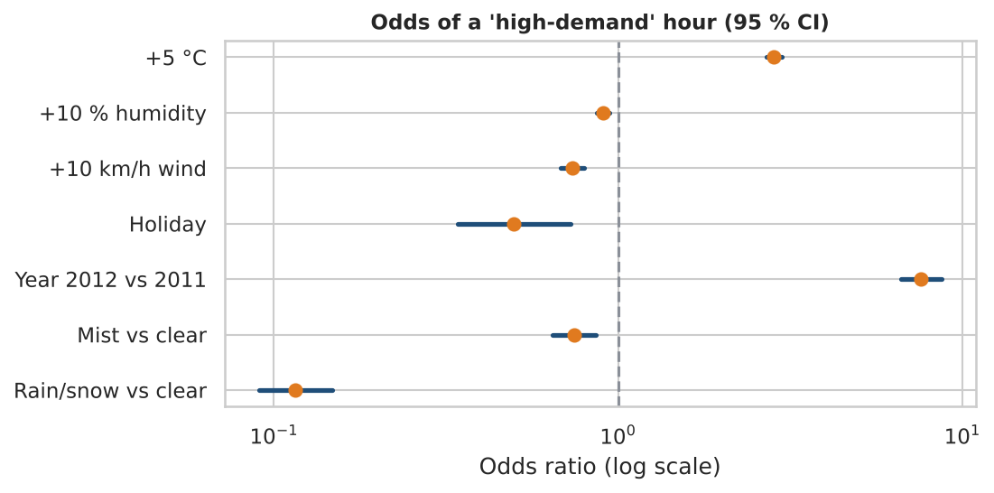
Figure 7. Odds ratios with 95 % confidence intervals (log scale); a value below 1 lowers the odds of a high-demand hour.
Interpretation. Holding everything else fixed: each +5 °C multiplies the odds of a high-demand hour by 2.84; rain or snow multiplies them by 0.12 (an 88 % reduction); +10 km/h of wind multiplies them by 0.74; +10 % humidity by 0.90; a public holiday by 0.50. The year effect (OR 7.6) reflects the growth of the system between 2011 and 2012 and is large because the median threshold is fixed across both years. All of these confidence intervals exclude 1. The hour and day-type terms are harmonic coefficients that only make sense jointly, so they are not interpreted one by one.

3.2 Discriminant analysis: LDA and QDA
Discriminant analysis models the distribution of the predictors within each class and applies Bayes' rule. Linear discriminant analysis (LDA) assumes Gaussian classes sharing one covariance matrix, which gives a linear decision boundary; quadratic discriminant analysis (QDA) lets each class have its own covariance, giving a curved boundary at the cost of many more parameters. Both were fitted on standardised features (QDA with a small regularisation, reg_param = 0.1, for stability). The class priors are balanced (0.50 / 0.50).
LDA behaves almost exactly like logistic regression (test AUC 0.952 versus 0.954; accuracy 0.877 versus 0.880), which is expected because both produce a linear boundary. LDA trades some precision for higher recall (0.924 versus 0.894). QDA is worse (AUC 0.935): the predictors include binary dummies and harmonic terms that are far from Gaussian, so the extra flexibility of separate covariances adds variance without capturing real structure. Full comparisons appear in Section 5.

3.3 Multinomial logit regression
To predict three demand levels the multinomial logit model estimates, for each level k versus a baseline (low demand), log( P(level k) / P(low) ) = β₀ₖ + βₖ·x. It was fitted by maximum likelihood with statsmodels (McFadden pseudo-R² = 0.5937). On the test set accuracy is 79.9 % and macro-F1 is 0.801. Mistakes are almost always to the neighbouring level (only 5 low hours were predicted high and 2 high hours predicted low), which is the sensible kind of error for an ordered outcome.
Table 4. Multinomial logit odds ratios relative to the low-demand level (all p < 0.01)
Effect (per unit) | Medium vs low: OR | High vs low: OR
Temperature, +1 °C | 1.22 | 1.44
Humidity, +1 % | 0.986 | 0.981
Wind speed, +1 km/h | 0.973 | 0.949
Holiday | 0.54 | 0.30
Year 2012 vs 2011 | 4.0 | 34.7
Mist vs clear | 0.74 | 0.60
Rain/snow vs clear | 0.108 | 0.017

The effects strengthen as one moves from medium to high: warmth helps more, and bad weather is much more damaging to reaching the high level (OR 0.017) than to reaching medium (OR 0.108).

3.4 Generalised linear models for counts: Gaussian, Poisson and Negative Binomial
A generalised linear model (GLM) has three parts: a distribution from the exponential family for y, a linear predictor η = xβ, and a link g(μ) = η. Rental counts are non-negative integers, so a Gaussian model (identity link, i.e. ordinary least squares) can predict negative values and assumes constant variance. Poisson regression uses a log link and assumes Var(y) = E(y). When variance exceeds the mean (overdispersion), standard errors are too small and p-values too optimistic. Negative Binomial (NB2) regression adds a dispersion parameter α so that Var(y) = μ + αμ².
All three were fitted with the same predictors: a separate hour profile for working and non-working days (48 levels), temperature, humidity, wind, holiday, year, weather and season. The Pearson dispersion statistic of the Poisson model is 14.28 (it should be about 1), confirming strong overdispersion. The NB dispersion parameter was estimated with the Cameron–Trivedi auxiliary regression (α = 0.0515) and brings the Pearson statistic down to 1.84. The Poisson standard error of the temperature coefficient is about 3.52 times smaller than the NB one, so Poisson inference would be badly over-confident.
Table 5. Count-regression comparison on the 20 % test set (rentals per hour)
Model | AIC | Dispersion | Train RMSE | Test RMSE | Test MAE
Gaussian GLM (OLS) | 160,793 | 6144.34 | 74.1 | 74.6 | 51.4
Poisson GLM | 285,710 | 14.28 | 60.1 | 62.2 | 38.7
Negative Binomial GLM | 140,482 | 1.84 | 65.1 | 67.6 | 40.5
Random forest regressor | – | – | 27.6 | 44.1 | 26.3

The NB model has by far the lowest AIC (140,482 versus 285,710 for Poisson and 160,793 for Gaussian), so it describes the data best. For pure point prediction the Poisson model has a slightly lower RMSE than NB (62.2 versus 67.6) because NB down-weights the large-count hours; the point predictions of both are very close in MAE. The Gaussian GLM is the worst, as expected. The random forest regressor is much more accurate (RMSE 44.1, MAE 26.3) because it learns non-linear interactions automatically, but its training RMSE (27.6) is far below its test RMSE, a sign of mild over-fitting, and it offers no coefficients for inference. The practical choice is therefore NB for explanation and random forest for prediction.
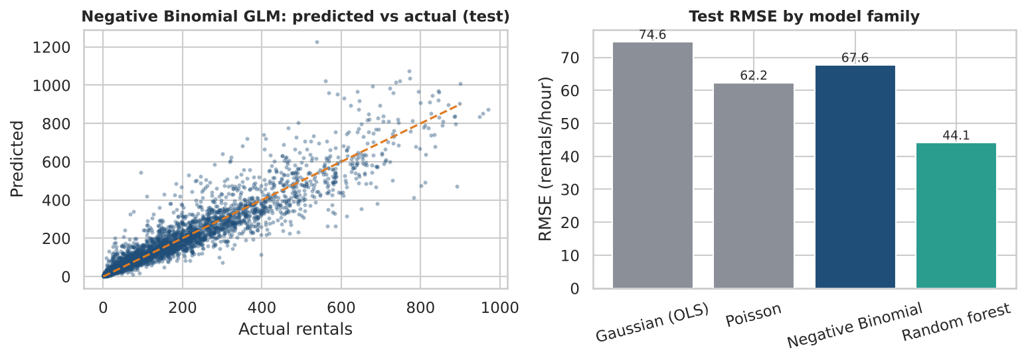
Figure 8. Left: Negative Binomial predictions versus actual counts on the test set. Right: test RMSE by model family.
Table 6. Negative Binomial rate ratios (all p < 0.001)
Effect | Rate ratio | 95 % CI | Change in expected rentals
Temperature, +1 °C | 1.036 | 1.035 – 1.037 | +3.6 %
Humidity, +10 % | 0.984 | 0.981 – 0.987 | -1.6 %
Wind speed, +10 km/h | 0.963 | 0.957 – 0.968 | -3.7 %
Holiday | 0.895 | 0.872 – 0.919 | -10.5 %
Year 2012 vs 2011 | 1.604 | 1.590 – 1.618 | +60.4 %
Mist vs clear | 0.940 | 0.930 – 0.950 | -6.0 %
Rain/snow vs clear | 0.586 | 0.576 – 0.598 | -41.4 %
Spring vs winter (season 2 vs 1) | 1.418 | 1.395 – 1.440 | +41.8 %
Summer vs winter (season 3 vs 1) | 1.318 | 1.291 – 1.344 | +31.8 %
Fall vs winter (season 4 vs 1) | 1.627 | 1.605 – 1.649 | +62.7 %

Rate ratios are multiplicative effects on the expected hourly count. Each extra °C raises expected rentals by about 3.6 %, rain or snow lowers them by about 41 %, a holiday by about 10 %, and 2012 is about 60 % above 2011. Season effects are measured against winter and are conditional on temperature, so they capture the remaining seasonal behaviour (for example, fall riders are more active than the temperature alone implies).

4. Time Series Analysis
For forecasting we aggregate to daily demand (731 consecutive days, no gaps). The last 60 days (2012-11-02 to 2012-12-31) are held out as the test period; models are fitted on 2011-01-01 to 2012-11-01.

4.1 Components of the series: trend, seasonality and noise
A classical additive decomposition with a 7-day period shows (Figure 9) a strong upward trend with a summer peak and a winter dip, a weak weekly pattern, and noise. The trend component carries about 86 % of the series' variance, the weekly seasonal component only about 0.4 % and the residual about 13 %. The weekly pattern is nevertheless visible: Sunday is lowest (-224 rentals relative to the weekly mean), Monday is -123, and Thursday and Friday are highest (+115 and +136). Weekly seasonality is weak because registered commuters (weekday) and casual riders (weekend) offset each other.
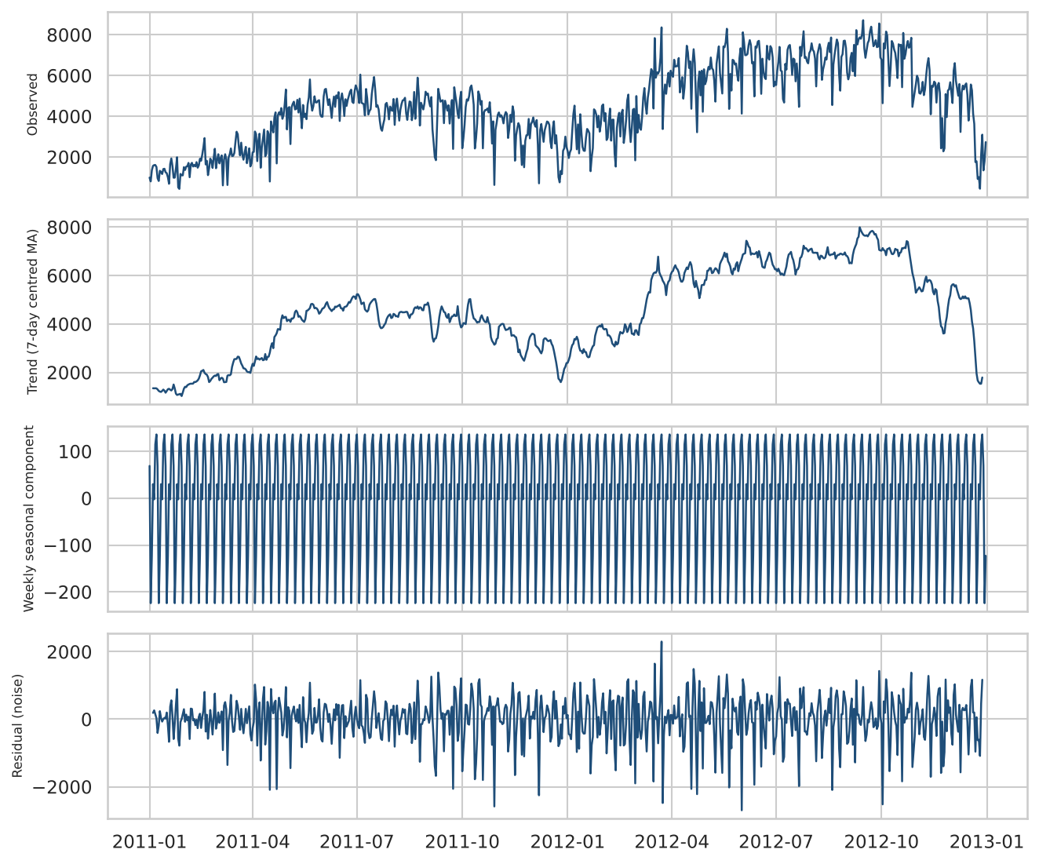
Figure 9. Additive decomposition of daily rentals (period = 7 days).

4.2 Outliers in the daily series
Daily demand is strongly weather-driven, and a few days are extreme. A robust rule (deviation from a 15-day rolling median, modified z-score above 6) flags 7 days (0.96 % of the series), the most extreme being 29 October 2012 with only 22 rentals, which coincides with Hurricane Sandy, and 27 August 2011 (1115), which coincides with Hurricane Irene. These flagged days were replaced by linear interpolation in the training data only; the test period is always scored against the raw observations. Without this step the last days of the training window would pull every forecast down.
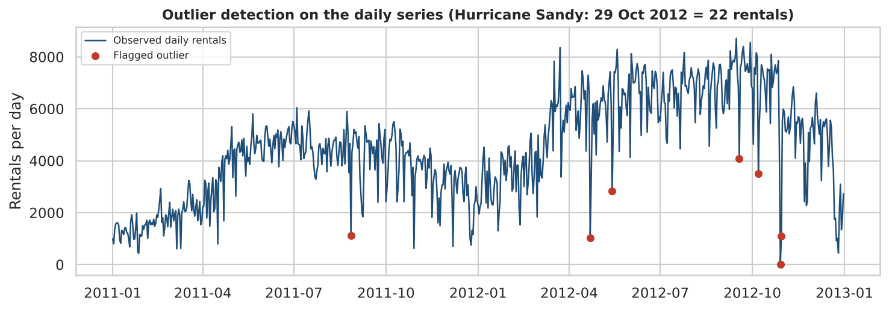
Figure 10. Daily rentals with the days flagged as outliers.

4.3 Stationarity and ACF/PACF
ARIMA-type models require a stationary series. The augmented Dickey–Fuller (ADF) test cannot reject a unit root for the level series (statistic -1.671, p = 0.4459), but the first difference is clearly stationary (statistic -10.953, p < 0.001), as is the combination of first and weekly (lag-7) differencing (statistic -9.271, p < 0.001). We therefore use d = 1, and D = 1 with a seasonal period of 7 in SARIMA. The ACF of the original series decays very slowly (non-stationary), and the differenced series shows short-memory structure with a seasonal signal at lag 7 that guides the choice of small AR/MA and seasonal orders.
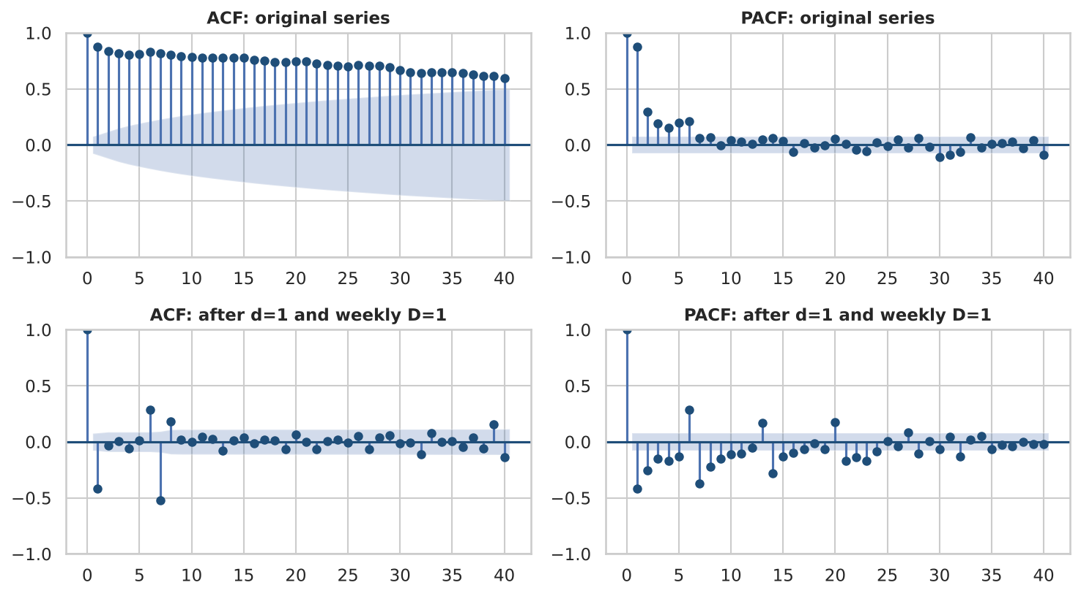
Figure 11. ACF and PACF of the training series, before and after differencing.

4.4 Models
- Baselines: naive (repeat last value) and seasonal naive (repeat the last week). Any useful model must beat these.
- ARIMA(p, d, q): a grid over p, q in 0–3 with d = 1 (16 models) selected by AIC gave ARIMA(3, 1, 3).
- SARIMA(p, d, q)(P, D, Q)₇: a grid over p, q in 0–2 and P, Q in 0–1 with d = D = 1 (36 models) selected SARIMA(1,1,1)(1,1,1)₇ by AIC; its residuals pass the Ljung–Box test for autocorrelation (p = 0.1637, 0.6035, 0.6273 at lags 7, 14, 21).
- Exponential smoothing: simple exponential smoothing, Holt's damped-trend method, and four Holt–Winters variants (additive/multiplicative seasonality, damped or not); the lowest-AIC variant uses additive damped trend with multiplicative weekly seasonality (α = 0.219).
- SARIMAX (regression with SARIMA errors): adds external regressors that are known in advance or forecastable: temperature, humidity, wind, holiday, bad-weather flag, working day, a 22–31 December indicator (holiday week) and a linear trend. Selected by AIC over 24 combinations with d = D = 0.

4.5 Hold-out results (60 days)
Table 7. Forecast accuracy over 2 Nov – 31 Dec 2012 (rentals per day); lower is better
Model | RMSE | MAE | MAPE %
Seasonal naive (t-7) | 2,398 | 1,786 | 85
Naive (last value) | 2,168 | 1,565 | 85
ARIMA(3, 1, 3) | 2,423 | 1,841 | 94
SARIMA(1, 1, 1)x(1, 1, 1, 7) | 2,491 | 1,958 | 98
SARIMAX (weather + trend) | 1,795 | 1,492 | 62
Simple exp. smoothing | 2,187 | 1,587 | 86
Holt (damped trend) | 2,227 | 1,631 | 87
Holt-Winters (mul seasonal, damped) | 2,140 | 1,555 | 84

The weather-and-calendar SARIMAX is the best model (RMSE 1,795, MAE 1,492), about 16 % better in RMSE than the best univariate result (Holt-Winters (mul seasonal, damped), 2,140; naive 2,168). The univariate ARIMA and SARIMA models are actually worse than the naive forecast over this horizon (Figure 12): demand fell from about 6,000 rentals per day to about 4,500 as winter arrived and then collapsed in the last ten days of December, and with only two years of data no univariate model can learn an annual cycle. The SARIMAX captures much of the late-December fall through the holiday-week regressor and the weather, although it still over-predicts most of November. MAPE is large for every model because it is dominated by a few very low days (for example 441 rentals on 26 December); RMSE and MAE are more informative here.
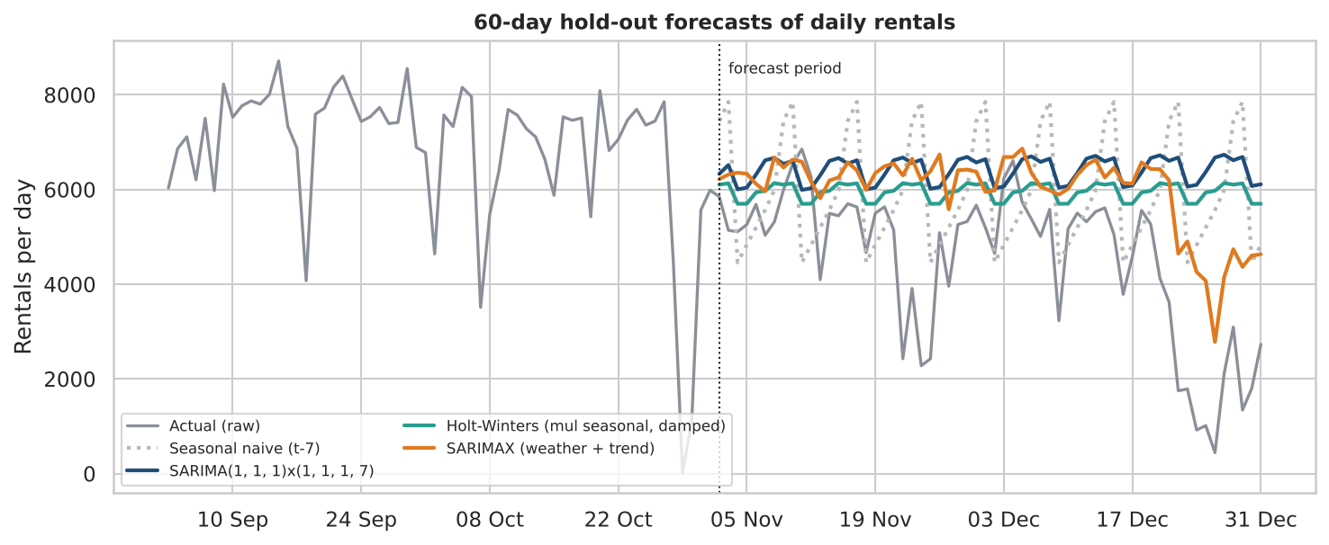
Figure 12. Forecasts versus actual daily rentals over the 60-day hold-out period.
SARIMAX coefficients (rentals per day, all other variables fixed): temperature +104 per °C (p < 0.001), humidity -26 per % (p < 0.001), wind -32 per km/h (p < 0.001), bad weather -942 (p < 0.001), holiday -381 (p = 0.005), 22–31 December -1570 (p < 0.001). The working-day coefficient (+18, p = 0.74) and the trend (p = 0.13) are not significant at the daily level. A Ljung–Box test shows slight remaining autocorrelation at lag 7 (p = 0.0448), so there is room for further improvement.

4.6 Rolling-origin evaluation and residual diagnostics
A single 60-day split can be lucky or unlucky. We therefore repeated the evaluation with an expanding window: four forecast origins, each predicting the next 30 days, with model orders held fixed.
Table 8. Rolling-origin RMSE for a 30-day horizon (rentals per day)
Forecast origin | Seasonal naive | SARIMA | Holt–Winters | SARIMAX
2012-09-02 | 1,317 | 1,071 | 1,200 | 1,188
2012-10-02 | 1,933 | 2,102 | 1,887 | 1,505
2012-11-01 | 1,882 | 1,765 | 1,439 | 1,595
2012-12-01 | 2,055 | 1,821 | 1,975 | 885
Mean RMSE | 1,797 | 1,690 | 1,625 | 1,293

SARIMAX has the lowest mean error (1,293) and is best in two of four folds; Holt–Winters (1,625) and SARIMA (1,690) both beat the seasonal-naive benchmark (1,797) on average. No model wins every fold, which is typical and argues for reporting averages across origins. Note that SARIMAX is given the actual weather of the forecast window; in production it would use weather forecasts, which add error, so its advantage here is an upper bound.
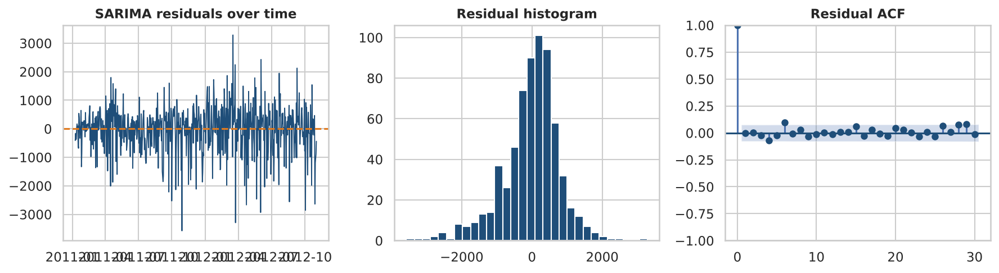
Figure 13. Residual diagnostics for the SARIMA model: residuals over time, histogram, and ACF.
The same pipeline (differencing, ACF/PACF, ARIMA/SARIMA, exponential smoothing and out-of-sample evaluation) applies directly to stock-price analysis; the main difference is that prices behave close to a random walk, so naive benchmarks are much harder to beat and volatility models would be needed for risk.

5. Model Validation and Optimization

5.1 Train–test split and cross-validation
Models must be judged on data they have not seen. We hold out 20 % of the hourly rows as a test set (stratified by the label) and never use it for tuning. Inside the 80 % training part we use stratified 5-fold cross-validation: the data are split into five parts, the model is trained on four and scored on the fifth, and the five scores are averaged. This gives a more stable estimate and a standard deviation (for logistic regression, CV F1 = 0.893 ± 0.006).
Random K-fold is not always appropriate. Hourly data are ordered in time and neighbouring hours are nearly identical, so random folds let the model 'peek' at the neighbours of each test hour. For the tuned random forest on the full data, random 5-fold CV gives a mean F1 of 0.933, but time-ordered folds (TimeSeriesSplit, always training on the past and testing on the future) give 0.852, with fold scores of 0.90, 0.86, 0.62, 0.95, 0.93. The weak third fold (0.62) shows how fragile a model is when the period it must predict has a different demand level from the training window (the median threshold was fixed over the whole two years). A final chronological hold-out, training until 2012-07-02 and testing on later data, gave F1 = 0.933 and AUC = 0.979, close to the random-split result, so the headline numbers are credible, but the time-ordered folds are the more honest estimate of real-world performance.

5.2 Performance metrics
- RMSE = √(mean of squared errors) and MAE = mean of absolute errors, for regression and forecasting; RMSE penalises large errors more, MAE is in the original units and robust.
- Precision = TP/(TP+FP), recall = TP/(TP+FN), and the F1-score = 2·precision·recall/(precision+recall), the harmonic mean of the two.
- AUC-ROC is the area under the curve of true-positive rate versus false-positive rate over all thresholds: 0.5 is random guessing and 1.0 is perfect ranking; it does not depend on the 0.5 cut-off.

5.3 Model comparison for the classification task
Table 9. Test-set performance (3,476 hours, threshold 0.5); the first four rows use default settings
Model | CV F1 | Accuracy | Precision | Recall | F1 | AUC
Logistic regression | 0.893 | 0.880 | 0.869 | 0.894 | 0.882 | 0.954
LDA | 0.890 | 0.877 | 0.844 | 0.924 | 0.882 | 0.952
QDA | 0.866 | 0.854 | 0.817 | 0.913 | 0.862 | 0.935
Random forest (default) | 0.929 | 0.931 | 0.920 | 0.944 | 0.932 | 0.982
Random forest (grid-tuned) | 0.929 | 0.931 | 0.920 | 0.944 | 0.932 | 0.982
Gradient boosting (random-tuned) | 0.943 | 0.944 | 0.930 | 0.961 | 0.945 | 0.986

Tree ensembles clearly beat the linear and quadratic models (AUC about 0.98 versus 0.95 or lower), because demand depends on interactions (hour × day type × weather) that a single linear boundary cannot capture. The tuned gradient-boosting model is best (accuracy 0.944, F1 0.945, AUC 0.986). Its confusion matrix has 1,666 true positives, 1,617 true negatives, 125 false positives and 68 false negatives.

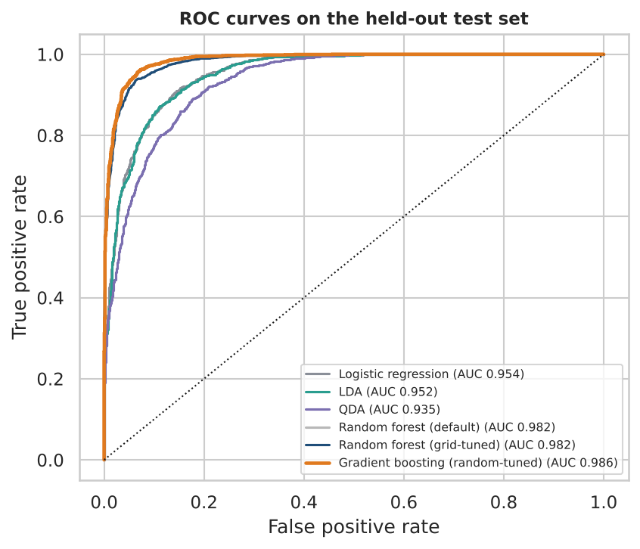
Figure 14. ROC curves of all classifiers on the test set.
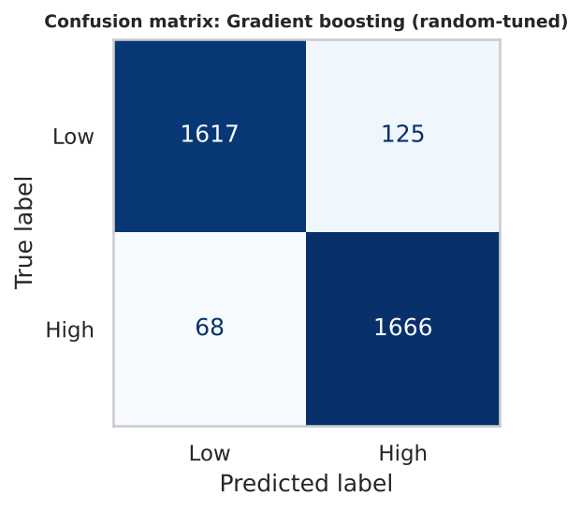
Figure 15. Confusion matrix of the best model on the test set.
What drives demand? In the tuned random forest, hour of day carries 48 % of the importance, followed by temperature (14 %), humidity (11 %) and wind (5 %), in line with the regression results.
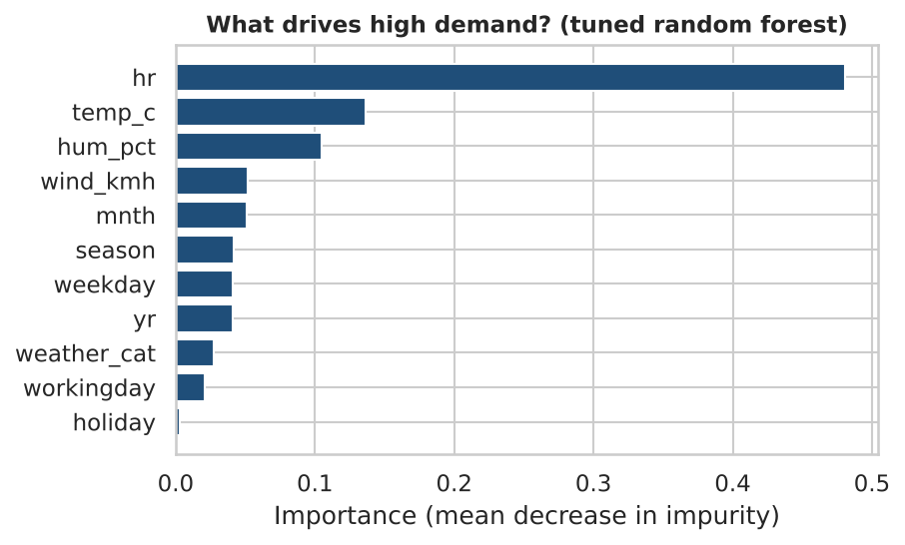
Figure 16. Feature importance in the tuned random forest.

5.4 Hyper-parameter tuning: grid search and random search
Grid search exhaustively evaluates every combination of a small grid. For the random forest we searched n_estimators ∈ {100, 200}, max_depth ∈ {6, 12, 20, none} and min_samples_leaf ∈ {1, 5, 10}: 24 combinations × 5 folds = 120 model fits. The best setting (n_estimators = 200, unlimited depth, min_samples_leaf = 1) has a CV F1 of 0.9294, identical to the default forest (0.9294), so for this data the default is already at the optimum of the grid; tuning does not always help and it is important to report that honestly.
Random search samples configurations from distributions instead, which covers a large continuous space with a fixed budget. For histogram gradient boosting we sampled 25 configurations of learning rate, depth, number of leaves, minimum leaf size and L2 penalty (5-fold CV each, 125 fits). The best configuration (learning rate 0.17, max depth 5, 51 leaves, min leaf 12, L2 = 0.07) reached CV F1 = 0.9429, an improvement of about 1.4 points over the forest, and F1 = 0.9452 on the untouched test set, so the CV estimate was reliable.

5.5 Overfitting and underfitting
A model underfits when it is too simple (high bias: poor on both training and validation data) and overfits when it memorises noise (low training error, high validation error). Figure 17 (left) shows this for decision trees. A depth-1 stump scores F1 ≈ 0.81 on both training and validation data (underfitting). As depth grows, training F1 rises toward 1.00, but cross-validated F1 peaks at depth 12 (0.920) and then stays flat or slips: the extra depth only memorises the training set (overfitting). The learning curve (middle) shows the same thing as a gap between training and validation scores: 0.085 for the unpruned tree versus 0.052 with depth limited to 12, and the validation curve is still rising, so more data would help.
Techniques used to control over- and under-fitting: (i) limiting tree depth and leaf size (pruning); (ii) bagging in random forests and shrinkage plus L2 penalty in boosting; (iii) L1 regularisation of logistic regression (right panel): with a very strong penalty (C = 10⁻⁴) all coefficients are zero and the model underfits (F1 = 0), and from C ≈ 0.03 upwards all 16 coefficients are retained with a flat F1 of about 0.89, so regularisation is not needed here beyond a mild setting; (iv) more data and cross-validated model selection; (v) simpler models when interpretability is required.
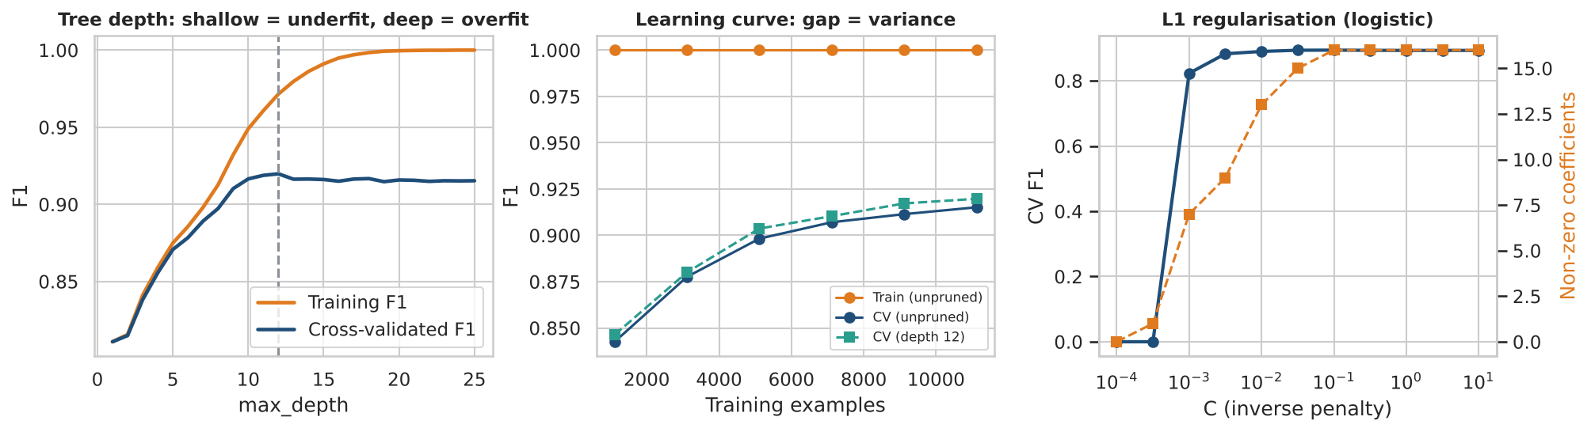
Figure 17. Left: validation curve over tree depth. Middle: learning curves. Right: L1 regularisation path for logistic regression.

6. Discussion and Recommendations

6.1 Summary of findings
Table 10. Summary of results
Task | Best model | Key metric
High vs low demand (binary) | Gradient boosting (random-search tuned) | F1 0.945, AUC 0.986
Interpretation of drivers | Logistic regression / NB GLM | Rain/snow: OR 0.12; +1 °C: +3.6 % rentals
Three demand levels | Multinomial logit | Accuracy 79.9 %, macro-F1 0.801
Hourly counts | Random forest (prediction); NB GLM (inference) | RMSE 44.1 (RF); AIC best for NB
60-day daily forecast | SARIMAX with weather and calendar | RMSE 1,795 (naive 2,168)

6.2 Operational recommendations
- Rebalancing before the commuter peaks: on working days demand is highest around 08:00 and 17:00–18:00; docks near employment centres need bikes in the morning and empty docks in the evening, and vice versa near residential areas.
- Weather-aware fleet planning: a rain or snow forecast cuts expected rentals by about 41 % (and the odds of a high-demand hour by about 88 %); trucks, staff and maintenance can be scheduled into those hours.
- Holiday and winter weeks: the Christmas-to-New-Year period shows demand roughly 1,500 rentals per day below normal even after controlling for weather; plan reduced operations.
- Use the classifier as a daily alert: a probability of high demand for each hour is a simple signal that dispatchers can act on, with the NB model used to explain why.

6.3 Limitations
- Only two years of data: annual seasonality cannot be learned, and the 60-day hold-out falls in winter where all univariate models fail.
- The weather used in SARIMAX is the observed weather, not a forecast, so its accuracy is an upper bound; city-level weather also hides local conditions.
- The binary label uses a median fixed over both years; demand growth makes later hours more often 'high'. Time-ordered validation reveals variation between periods (one fold had F1 = 0.62).
- Wind speed zeros (12.5 % of rows) are probably a measurement limitation; the one-day humidity fault was imputed, not corrected at source.
- No station-level data: the models cannot say where bikes are needed, only how many in total.

6.4 Future work
- Add station-level and event data; model the casual and registered riders separately.
- Use zero-inflated or hurdle models for night hours, and gradient-boosted Poisson/NB models for counts.
- Add annual seasonality (Fourier terms) once more years of data are available, and probabilistic (interval) forecasts.
- Deploy as a scheduled pipeline with weather-forecast inputs, monitoring of drift and a fairness check across neighbourhoods.

7. Conclusion
Using one real dataset, this project walked through the full predictive-analytics workflow. Careful preparation (humidity fault, outliers, leakage, collinearity, cyclic features) mattered as much as the choice of algorithm. Logistic and Negative Binomial models gave interpretable, statistically sound explanations of demand: warmer, calmer, clearer days and commuter hours drive usage, and bad weather removes about 41 % of it. Tree ensembles were the most accurate predictors (AUC 0.986), and the importance of choosing the right family was shown by the extreme overdispersion of the counts. In forecasting, regression with SARIMA errors using weather and calendar information beat all univariate time-series models, which could not anticipate the seasonal downturn. Finally, honest validation (time-ordered folds, a held-out test set, reporting when tuning did not help) separated trustworthy results from flattering ones.

References
Fanaee-T, H. and Gama, J. (2014). Event labeling combining ensemble detectors and background knowledge. Progress in Artificial Intelligence, 2(2–3), 113–127. Dataset: UCI Machine Learning Repository, Bike Sharing Dataset (ID 275).
James, G., Witten, D., Hastie, T. and Tibshirani, R. (2021). An Introduction to Statistical Learning, 2nd ed. Springer.
Hyndman, R. J. and Athanasopoulos, G. (2021). Forecasting: Principles and Practice, 3rd ed. OTexts.
Cameron, A. C. and Trivedi, P. K. (2013). Regression Analysis of Count Data, 2nd ed. Cambridge University Press.
Box, G. E. P., Jenkins, G. M., Reinsel, G. C. and Ljung, G. M. (2015). Time Series Analysis: Forecasting and Control, 5th ed. Wiley.
Pedregosa, F. et al. (2011). Scikit-learn: Machine learning in Python. Journal of Machine Learning Research, 12, 2825–2830.
Seabold, S. and Perktold, J. (2010). Statsmodels: Econometric and statistical modeling with Python. Proceedings of the 9th Python in Science Conference.

Appendix A: Syllabus coverage map
Table 11. Mapping of syllabus topics to report sections
Syllabus unit and topics | Where covered
Introduction: definition, importance, scope; predictive vs descriptive vs prescriptive; industries; ethics | Section 1.1–1.4
Data preparation: collection and challenges; cleaning, missing values, outliers | Sections 2.1–2.2
EDA: visualisation; feature engineering and selection | Sections 2.3–2.4
Logistic regression for binary classification; estimation of coefficients | Section 3.1
Discriminant analysis: LDA and QDA | Section 3.2
Multinomial logit regression | Section 3.3
Generalised linear regression, Poisson and Negative Binomial regression | Section 3.4
Time series basics: trend, seasonality, noise | Sections 4.1–4.3
ARIMA, SARIMA, exponential smoothing; forecasting applications (demand; stock-price note) | Sections 4.4–4.6
Cross-validation and train-test splits | Section 5.1
Performance metrics: RMSE, MAE, F1-score, AUC-ROC | Sections 5.2–5.3
Hyper-parameter tuning: grid search and random search | Section 5.4
Techniques to handle overfitting and underfitting | Section 5.5

Appendix B: Reproducing the results
All results in this report are produced by the single script predictive_analytics_bike_demand.py (submitted as the Project Code). Requirements: Python 3.10+, pandas, numpy, scipy, matplotlib, seaborn, scikit-learn and statsmodels. Place hour.csv and day.csv from the UCI Bike Sharing Dataset in a folder named data next to the script (the script downloads them automatically if they are missing) and run: python predictive_analytics_bike_demand.py. The script writes all figures to a figures folder and every number quoted here to results.json. A fixed random seed (42) makes the run reproducible; runtime is a few minutes on an ordinary laptop.

